Software Requirements Specification

for

PC2 Web Team Interface

**Version 2.0**

**Prepared by:   
Josie Isaacson  
Andrew Combs  
Ethan Holman  
Danielle Frodge**

**EWU CS Department**

**Winter 2019/Spring 2019**

**Table of Contents**

Introduction **3**

Purpose 3

Intended Audience and Reading Suggestions 3

Mission Statement 3

References 3

Overall Description **3**

Product Perspective 3

Product Functions 4

User Classes and Characteristics 5

Operating Environment 5

Design and Implementation Constraints 6

User Documentation 6

Assumptions and Dependencies 7

External Interface Requirements **7**

User Interfaces 7

Host Platform 7

Software Interfaces 7

Communications Interfaces 8

System Features **8**

Team Login 8

Submit Judged Run 9

Submit Test Run 11

View Runs 14

Submit Clarification 16

View Clarifications 17

Set Options 19

About Information 20

Other Nonfunctional Requirements **21**

Performance Requirements 21

Security Requirements 21

Software Quality Attributes 21

Business Rules 22

Other Requirements **22**

**Revision History**

|  |  |  |  |
| --- | --- | --- | --- |
| **Name** | **Date** | **Reason For Changes** | **Version** |
| Josie Isaacson | 5/8/19 | Revised per client clarifications/critique | 2.0 |
| Josie Isaacson | 6/10/19 | Revised to reflect UI changes | 2.0 |

# Introduction

## Purpose

Product: PC2 Web Team Interface (WTI) Version 2.0

The purpose of this document is to detail the specified requirements for the PC2 Web Team Interface (WTI).

## Intended Audience and Reading Suggestions

This document is intended to be used by the members of the current project team and any future team developers that will be implementing and verifying functionality of the WTI. A table of abbreviations and acronyms can be found in Appendix A.

## Mission Statement

Our objective is to provide a single web-based interface that maintains the functionality of the current Version 9 (V9) Application Team Client while replacing functionality from the V9 EWTeam Web Client. The purpose of this interface is to allow for more efficient contest set up by not requiring individual installation on each team machine.

## References

[1] “Contest API.” Contest API - ICPC-Contest Control Standard, ACM, 11 Dec. 2018, 22:51, clics.ecs.baylor.edu/index.php?title=Contest_API.

[2] PC2 V9 System Reference. https://pc2.ecs.csus.edu/pc2docs.html

[3] “About the ACM Organization.” Association for Computing Machinery, [www.acm.org/about-acm/about-the-acm-organization](http://www.acm.org/about-acm/about-the-acm-organization).

# Overall Description

## Product Perspective

The purpose of the WTI is to provide a web implementation of a web client for contest teams to use in accessing the existing PC2 system. Currently the system requires installation on every contest computer in order to access it. Implementing a web interface will reduce contest setup overhead. WTI will be interfacing with the V9 PC2 system implementation.

## Product Functions

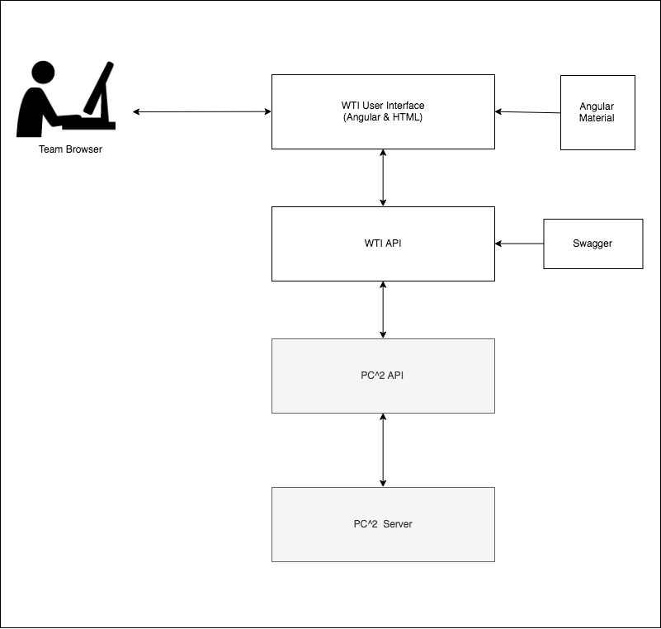

WTI shall provide the following functions:

* Login
* Submit Judged Run
* Request Clarification
* View Clarification
* Submit Test Run
* View Judged Runs
* View Test Runs
* Set Options

The following functions are discussed in 4.1.

## User Classes and Characteristics

Teams will be made up of groups of (3-4) users. These users are usually college students in their third or fourth year. College students typically have experience with web applications. Teams will be interacting with the WTI system when participating in programming competitions during an ACM event.

Teams will use the following features of WTI during a contest:

* Login
* Submit Judged Run
* Request Clarification
* View Clarification
* Submit Test Run
* View Judged Runs
* View Test Runs
* Set Options

## Operating Environment

|  |  |
| --- | --- |
| Operating System | Support |
| Linux, Windows, and MacOSX | All Current Versions |

|  |  |
| --- | --- |
| Browser | Version |
| Chrome | 72.0.3626.81+ |
| Safari | 12.0.2+ |
| Internet Explorer | 11+ |
| Oasis | TBD |
| Firefox | 65.0+ |

## Design and Implementation Constraints

WTI is limited to:

|  |  |
| --- | --- |
| Memory Restrictions | JVM can only handle a certain amount of memory based on what server it is running on. |
| Language | WTI shall be bound to using Java EE 8 and using the Angular 7 framework. |
| Interfaces | WTI will interface with existing working system to pass information between the team users and the system. |
| Standards | WTI shall use industry best standards by utilizing best industry practices of both Angular and Java. |

## User Documentation

WTI will be provided with the following documentation:

|  |  |
| --- | --- |
| User Manual | Detailed user manual that will outline basic usage of running the interface. |
| Installation | Documentation on requirements to run application and how to properly set-up and run. |
| Technical Specifications | Documentation for future developers who will maintain and upgrade the application. |
| Coding Guidelines | Specified coding guidelines that will set-up coding standards for application extension. |
| Swagger Documentation | Documentation describing the WTI API endpoints. |
| JavaDoc Documentation | Documentation describing the WTI API methods. |

## Assumptions and Dependencies

*Java:* WTI will require the user to have a JRE to be able to utilize WTI. Users without it will be unable to run the application.

*PC2**Application:* WTI shall depend upon V9 software installed on the server.

*PC2 API:* WTI shall depend upon the PC2API in order to communicate with existing PC2 system.

*PC2**Server:* WTI shall depend upon the PC2 server running in order to access the PC2 system.

See Technical Specifications for additional dependencies.

# External Interface Requirements

## User Interfaces

* The WTI will follow the Material Design Language (https://material.io/). Specifically, the Angular Material UI library will be utilized: (https://material.angular.io/).
* All components of the WTI will have a consistent look and feel, including but not limited to:
  + Dialogs used for creating submissions and clarifications.
  + Snackbar component used for errors and UI feedback.
* Application will be responsive to work across multiple screen resolutions.
  + 480px - 1920px will be tested.
  + 1366px will be assumed the ‘preferred’ resolution.
* Application will be functional and tested on a touchscreen.
* Errors will be displayed to the user via snackbar alerts.
* Application mockup screens will be hosted on Figma, accessible here: https://www.figma.com/files/project/1619309/WTI

## Host Platform

The WTI will require a host computer that is:

* Running a supported operating system and supported browser.
* Has network connectivity to client (competitor) machines.

## Software Interfaces

The WTI implementation is dependent upon the following:

* Java EE 8
* Angular 7
* PC2 API
* External PC2 Server

See Technical Specifications for additional dependencies.

## Communications Interfaces

* The WTI uses a RESTful web API, accessible at port 8080.
* Websockets will be used for some types of communication between the UI and API portions of the WTI [5.1].
* The WTI will communicate with the V9 PC2 server applications.

# System Features

## Team Login

4.1.1 Description

Team login will provide an interface for the team to enter login credentials in order to access to the team main screen.

4.1.2 Stimulus/Response Sequences

|  |  |
| --- | --- |
| Stimulus: | User opens WTI. |
| Response: | Login screen displays fields for the user to input a team name/id and a team password. |
| Stimulus: | User enters login credentials and clicks the login button. |
| Response: | Credentials verified by the system.   * *If credentials are correct:* Login screen will change to reveal the team main screen. * *If credentials are incorrect:* User will be notified of the incorrect credentials and allowed to re-input credentials into the provided fields. |

4.1.3 Functional Requirements

|  |  |
| --- | --- |
| Team Name Input Field: | Text input field that allows alphanumeric characters and special characters. |
| Team Password Input Field: | Text input field that allows alphanumeric characters and special characters. |
| Login Button: | Login button is present and can only be triggered when login credential fields are filled. |
| Verification Process: | Verifies that user credentials are correct.   * *If credentials are invalid:*   + Message appears on screen informing user that username and/or password are invalid and to try inputting credentials again.   + Fields are cleared to allow for new credentials to be inputted. * *If credentials are valid:*   + Login screen will be cleared and reveal team main screen. |

## Submit Judged Run

* + 1. Description

Submit judged run will allow the user to select the problem, language, main file, and any additional files needed and then submit the run to be judged by the contest judges.

* + 1. Stimulus/Response Sequences

|  |  |
| --- | --- |
| *Select Problem* | |
| Stimulus: | User clicks on the problem list. |
| Response: | If contest has started, WTI displays a list of the problems available for the user to select from. If contest has not started, problem list will not be available for the user to see. |
| *Select Language* | |
| Stimulus: | User clicks on the language list. |
| Response: | WTI displays a list of the languages available for the user to select from. |
| *Select Main File* | |
| Stimulus: | User clicks button to select a main file. |
| Response: | WTI reveals file system window for the user to choose a main file as selection. |
| Stimulus: | User chooses main file from file system window. |
| Response: | WTI saves selection as file to be submitted as main file. |
| *Select Additional File(s)* | |
| Stimulus: | User clicks button to select additional file(s). |
| Response: | WTI reveals file system window for the user to choose an additional file as selection. |
| Stimulus: | User chooses additional file(s) from file system window. User can multi-select files. |
| Response: | WTI saves selection as file(s) to be submitted as additional file(s). |
| *Submission and Field Verification* | |
| Stimulus: | User clicks submit run button. |
| Response: | WTI checks that required fields are filled.   * *If all required fields filled:*   + WTI submits problem, language, and file information to the PC2 server. * *If all required fields not filled:*   + WTI submit button is not available until required fields filled. |
|  |  |

* + 1. Functional Requirements

|  |  |
| --- | --- |
| Problem List Field: | List is displayed that contains all current contest problems as choices for selection. List will only be displayed if the contest has started. |
| Language List Field: | List is displayed that contains all current allowed languages for the given contest as choices for selection. |
| Main File Select Field: | * Clickable button that will trigger a file system window to open for user to select file. * Text field that lists the name of the file selected by the user. |
| Additional Files Select Field: | * Clickable button that will trigger a file system window to open for user to select file. * Text field that lists the name of the file(s) selected by the user. * User can multi-select files. |
| Submit Run Button: | Submit run button is present. |
| Cancel Button: | Cancel button is present. When triggered, all fields will be cleared and reset to default values. |
| Judged Run Tag: | Tag marking this run as a judged run. Default for runs will be that they are a judged run. |

## Submit Test Run

* + 1. Description

Submit test run will allow the user to select the problem, language, main file, any additional files needed, and a test data file. User can then submit the run to be tested, but not judged.

* + 1. Stimulus/Response Sequences

|  |  |
| --- | --- |
| *Select Problem* | |
| Stimulus: | User clicks on the problem list. |
| Response: | If contest has started, WTI displays a list of the problems available for the user to select from. If contest has not started, problem list will not be available for the user to see. |
| *Select Language* | |
| Stimulus: | User clicks on the language list. |
| Response: | WTI displays a list of the languages available for the user to select from. |
| *Select Main File* | |
| Stimulus: | User clicks button to select a main file. |
| Response: | WTI reveals file system window for the user to choose a main file as selection. |
| Stimulus: | User chooses main file from file system window. |
| Response: | WTI saves selection as file to be submitted as main file. |
| *Select Additional File(s)* | |
| Stimulus: | User clicks button to select additional file(s). |
| Response: | WTI reveals file system window for the user to choose an additional file as selection. |
| Stimulus: | User chooses additional file(s) from file system window. User can multi-select files. |
| Response: | WTI saves selection as file(s) to be submitted as additional file(s). |
| *Select Test Data File* | |
| Stimulus: | User clicks button to select test data file. |
| Response: | WTI reveals file system window for the user to choose a test data file as selection. |
| Stimulus: | User chooses test data file from file system window. |
| Response: | WTI saves selection as file to be submitted as the test data file. |
| *Submission and Field Verification* | |
| Stimulus: | User clicks submit test button. |
| Response: | WTI checks that required fields are filled.   * *If all required fields filled:*   + WTI submits problem, language, and file information to the PC2 server. * *If all required fields not filled:*   + WTI submit button is not available until required fields filled. |

* + 1. Functional Requirements

|  |  |
| --- | --- |
| Problem List Field: | List is displayed that contains all current contest problems as choices for selection. List will only be displayed if the contest has started. |
| Language List Field: | List is displayed that contains all current allowed languages for the given contest as choices for selection. |
| Main File Select Field: | * Clickable button that will trigger a file system window to open for user to select file. * Text field that lists the name of the file selected by the user. |
| Additional Files Select Field: | * Clickable button that will trigger a file system window to open for user to select file(s). * Text field that lists the name of the file(s) selected by the user. * User can multi-select files. |
| Test Data File Select Field: | * Clickable button that will trigger a file system window to open for user to select file. * Text field that lists the name of the file selected by the user. |
| Submit Test Button: | Submit test button is present. |
| Cancel Button: | Cancel button is present. When triggered, all fields will be cleared and reset to default values. |
| Test Run Tag: | Tag marking this run as a test run. |

## View Runs

* + 1. Description

View runs will allow the user to view a list of all submitted runs, including submitted runs and submitted tests. This list can be filtered by run type, language, judgment, and/or problem.

* + 1. Stimulus/Response Sequences

|  |  |
| --- | --- |
| *View All Runs* | |
| Stimulus: | User chooses to view runs with no filter option indicated. |
| Response: | WTI displays the list of all prior runs. Test runs will have a clickable link that will display a pop-up to view the results of the submitted test run. |
| *View Runs Filtered By Run Type* | |
| Stimulus: | User chooses to view runs with the run type filter option on. User clicks on either Judged or Test under the Run Type filter heading. |
| Response: | WTI displays the list of all prior runs of that run type. |
| *View Runs Filtered By Language* | |
| Stimulus: | User chooses to view runs with the language filter option on. |
| Response: | WTI displays list of languages to filter by. |
| Stimulus: | User chooses language to filter by. |
| Response: | WTI displays list of prior runs submitted in the specified language. |
| *View Runs Filtered By Judgment* | |
| Stimulus: | User chooses to view runs with the judgment filter option on. |
| Response: | WTI displays list of judgments to filter by. |
| Stimulus: | User chooses judgment to filter by. |
| Response: | WTI displays list of prior runs submitted with the specified judgment. |
| *View Runs Filtered By Problem* | |
| Stimulus: | User chooses to view runs with the problem filter option on. |
| Response: | If the contest has started, WTI displays the list of problems to filter by. If the contest has not started, user cannot see list of problems. |
| Stimulus: | User chooses problem to filter by. |
| Response: | WTI displays list of prior runs submitted for the specified problem. |

* + 1. Functional Requirements

|  |  |
| --- | --- |
| Prior Run List Field: | List is displayed that contains prior runs; either all prior runs or filtered prior runs. |
| Run Type Filter Indicator: | Radio button menu that allows the user to indicate a preference to filter by run type. Run type options are Both to apply no run type filter (default), Judged to filter by judged runs, or Test to filter by test runs. |
| Language Filter Indicator: | Drop down menu that allows the user to indicate a preference to filter by language. |
| Language Filter Field List: | List is displayed that contains all languages available in current contest as filter options. |
| Judgment Filter Indicator: | Drop down menu that allows the user to indicate a preference to filter by judgment. |
| Judgment Filter Field List: | List is displayed that contains all judgment types available in current contest as filter options.  Possible judgment types are:   * Accepted * Compile Error * Run Time Error * Time Limit Exceeded * Wrong Answer * Output Limit Exceeded * Memory Limit Exceeded * Judge Error * Pending |
| Problem Filter Indicator: | Drop down menu that allows the user to indicate a preference to filter by problem. |
| Problem Filter Field List: | List is displayed that contains all problems available in current contest as filter options. List will only be displayed if the contest has started. |
| View Test Results Link | Test runs will have a clickable link that will display a pop-up to view the results of the submitted test run. |

## Submit Clarification

* + 1. Description

Submit clarification will allow a user to select a problem and type in a clarification question to be submitted to the PC2 server.

* + 1. Stimulus/Response Sequences

|  |  |
| --- | --- |
| *Select Problem* | |
| Stimulus: | User clicks submit clarification button. |
| Response: | If contest has started, WTI displays a list of the available contest problems. |
| Stimulus: | User selects problem from list. |
| Response: | WTI saves problem selection. |
| *Enter Clarification Question* | |
| Stimulus: | User clicks submit clarification button. |
| Response: | WTI displays a text box that can be edited. |
| Stimulus: | User types in clarification question and clicks submit clarification. |
| Response: | WTI saves user’s clarification question. |
| Stimulus: | User chooses to either submit clarification or cancel. |
| Response: | *If user chooses to submit:*   * WTI will save text input, verify that problem has been selected and that text box contains text, and submit to the PC2 server.   *If user chooses to cancel:*   * WTI will clear all submitting fields and return the display to showing clarifications page view. |

* + 1. Functional Requirements

|  |  |
| --- | --- |
| Submit clarification button: | Submit clarification button is present. When triggered it will reveal the submit clarification pop-up view. |
| Problem field list: | List is displayed that contains all current contest problems available. List will only be displayed if the contest has started. |
| Clarification message text box: | Text box has basic editing functionality, where user can type in a clarification question/message. Only plain text is allowed. |
| Submit button: | Submit clarification button is present.   * *If all required fields filled:*    + WTI will send the user’s clarification question/message to the PC2 server. * *If all required fields not filled:*    + WTI submit button is not available until required fields filled. |
| Cancel button: | Cancel button is present. When triggered, WTI will clear all fields in the submit clarification view and return the screen to the team main clarifications view. |

## View Clarifications

* + 1. Description

View clarifications will allow a user to view all submitted clarifications and all judge responses (if any). Clarifications displayed shall have the option to be filtered by problem and/or by recipient type (either clarifications only for current team or by clarifications for all teams to see).

* + 1. Stimulus/Response Sequences

|  |  |
| --- | --- |
| *View All Clarifications and Responses* | |
| Stimulus: | User chooses to view all clarifications and responses with no problem filter chosen. |
| Response: | WTI displays all clarifications submitted with corresponding judge responses (if any). |
| *View Clarifications and Responses Filtered By Problem* | |
| Stimulus: | User chooses to view all clarifications and responses filtered by specific problem. |
| Response: | If the contest has started, WTI displays a list of problems available for contest. |
| Stimulus: | User selects problem to filter by. |
| Response: | WTI displays all clarifications and responses for selected problem only. |
| *View Clarifications and Responses Filtered By Recipient* | |
| Stimulus: | User chooses to view all clarifications and responses filtered by recipient. Only two choices are available for this filter: current team or all teams (a clarification sent from judges intended for all teams to view). |
| Response: | WTI displays all clarifications and responses for selected recipient only. |

* + 1. Functional Requirements

|  |  |
| --- | --- |
| Problem filter field list: | List is displayed that contains all current contest problems available. List will only be displayed if the contest has started. |
| Recipient filter radio buttons: | Radio buttons displayed with options of current team, all teams, or both. |
| Clarification and response message display: | Display is present. It will contain fields for recipient, problem, clarification question, and judge response (or pending if judge has not responded yet). |

## Set Options

* + 1. Description

Set options will allow user to change specific WTI options, at the discretion of the contest administrator. Allowable options can include such things as changing the team password, restricting certain pop-up windows from displaying, and other options yet to be determined at this time.

* + 1. Stimulus/Response Sequences

|  |  |
| --- | --- |
| *Changing Team Password [Not Implemented Currently]* | |
| Stimulus: | User chooses to change team password. |
| Response: | WTI reveals text interfaces for entering current password, entering new password, and re-entering of new password. |
| Stimulus: | User fills in text fields for current password, new password, and re-entering new password and clicks submit button. |
| Response: | WTI verifies that current password is correct and that new password and re-entered new password match.   * *If verified:* WTI notifies PC2 server of password change. * *If not verified:* WTI alerts user of problem. Problem could be incorrect current password or new password and re-entered new password not matching. |
| *Disabling/Enabling Pop-Up Windows* | |
| Stimulus: | User chooses to disable/enable pop-up windows. |
| Response: | WTI changes interface options to disable or enable certain pop-up windows. |

* + 1. Functional Requirements

|  |  |
| --- | --- |
| Change password button: | Change password button is present. When triggered, it will reveal the change password dialog. |
| Change password dialog: | Contains three text fields and a submit button.  Three text fields:   * Current Password * New Password * Re-Enter New Password   When the submit button is triggered, WTI will verify that all required fields are filled in. Verification will also include that current password is valid and that new password and re-enter new password match. |
| Pop-up windows dialog: | Contains two categories (runs and clarifications) each with two display fields with radio buttons (enable/disable). Two user choices will be either enable or disable pop-up windows. |
| Other set options features: | TBD |

## About Information

* + 1. Description

About information will allow a user to view information about PC2 and its creators.

* + 1. Stimulus/Response Sequences

|  |  |
| --- | --- |
| *View About Information* | |
| Stimulus: | User clicks “About” link at the bottom of any WTI page. |
| Response: | About pop-up window is displayed containing about information. |
| Stimulus: | User clicks the Close button. |
| Response: | About pop-up window is closed. |

* + 1. Functional Requirements

|  |  |
| --- | --- |
| About link: | Link at the bottom of any WTI page that when clicked will trigger the pop-up about window to be displayed. |
| About information view: | Pop-up window that will display information about the PC2 system and its creators. |

# Other Nonfunctional Requirements

## Performance Requirements

The WTI (both the web interface and backend) will be developed in an efficient manner. The client application (UI) portion of the WTI will need to be in contact frequently with the server portion of the WTI. Web sockets will be utilized, all communications will be event‐driven, and no polling will take place anywhere in the system.

## Security Requirements

The WTI shall use HTTPS for all communications between the client and the server. Encrypted transmissions include, but are not limited to: admin information, team information, login credentials, and team file submissions. Such encryption will prevent outside interference or data compromise.

User shall be required to use a username and password to login to the WTI. These login credentials identify the team during the contest and are assigned by the contest administrator. Changing of passwords or allowing teams to change passwords via the Options feature is at the sole discretion of the contest administrator.

## Software Quality Attributes

The WTI will be developed to run across all platforms. The WTI will be designed with users in mind, providing an intuitive experience. All parts of the WTI will be tested before release to ensure these goals are met.

The Angular/UI Codebase will:

* Have unit tests on major services and components.
* Follow coding standards established by the team (see ‘Coding Standards’ document).
* Follow industry best practices.
* Be designed using minimal dependencies and libraries.

The Java/API Codebase will:

* Have unit tests for each endpoint.
* Follow coding standards established by the team (see ‘Coding Standards’ document).
* Follow industry best practices.

## Business Rules

All WTI REST endpoints must be consistent with the CLICS Contest API Specification as implemented by the PC2 V9 system and referenced in Section 1.4.1.

A user must be authenticated before using the resources via API calls or using the web interface. The administrator may disable some functions of the WTI. These include but are not limited to: the ability to change team password.

# Other Requirements

TBD

**Appendix A: Glossary**

|  |  |
| --- | --- |
| ACM: | Association for Computing Machinery. Society known for sharing and expanding knowledge growth for computer scientists. |
| JDK: | Java Development Kit |
| JVM: | Java Virtual Machine |
| V9: | Version 9. Consists of Application Team Client and EWTeam Client, PC2 Server, a PC2 Judge, a PC2 Scoreboard, an Event Feed, an API, and other components within the PC2 system. |
| User: | A person who interacts with or uses the WTI. |
| WTI: | The Web Team Interface (WTI) is the working name for this programming contest team interface. |

**Appendix B: To Be Determined List**

Section 2.4 Oasis version.

Section 4.7 Set Options may contain further features as determined by client at a later date.

Section 6 Other Requirements

**Appendix C: WTI Screenshots**

**Login**

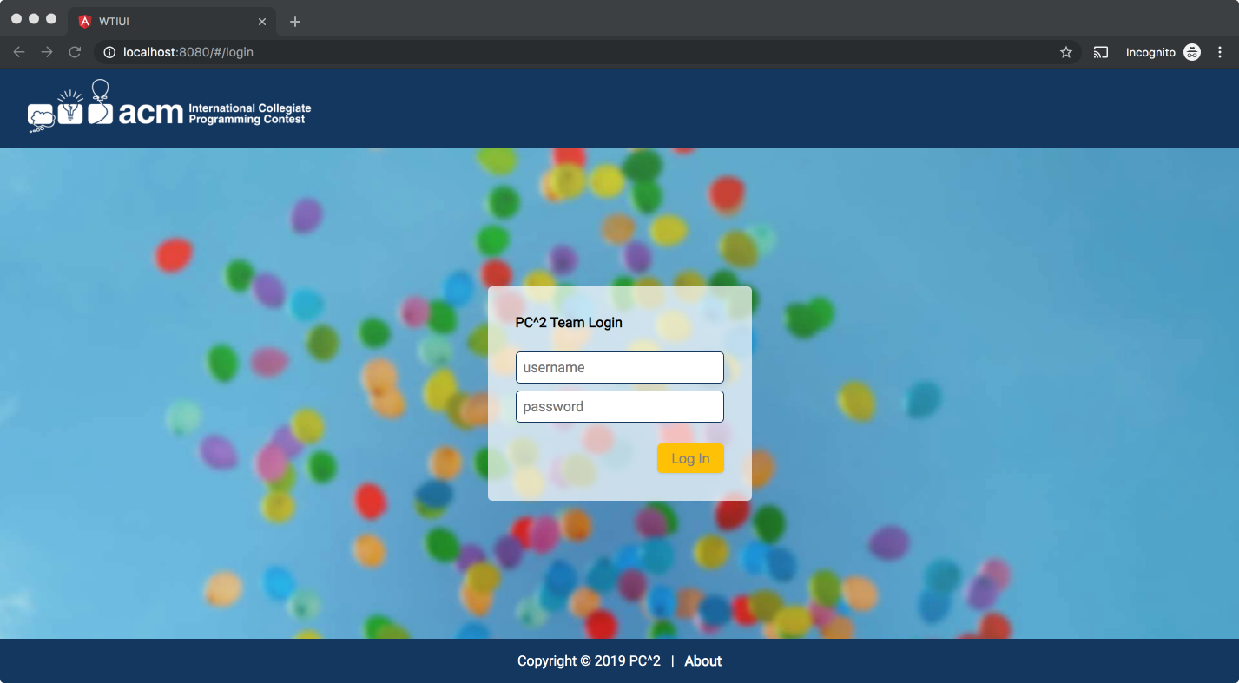

**View Runs**

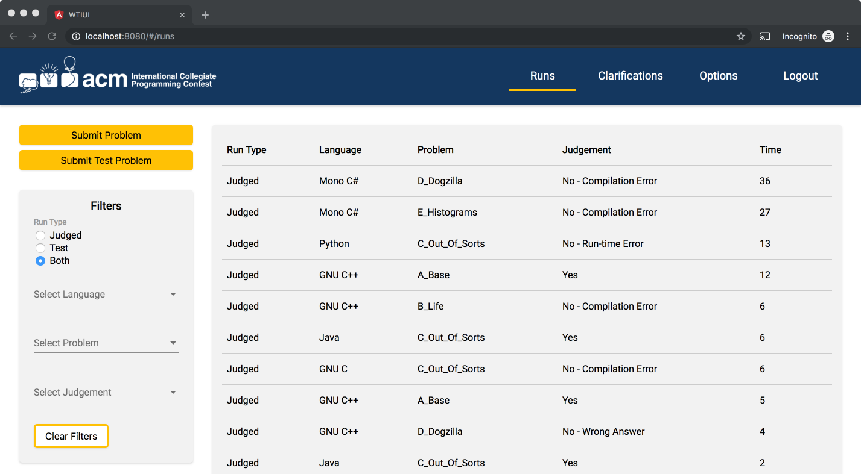

**Submit a Problem**

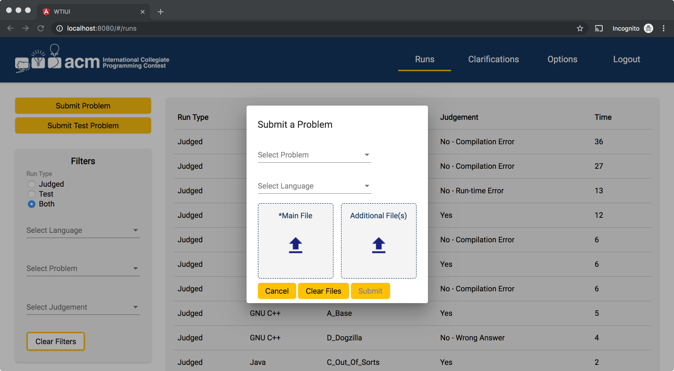

**Submit a Test Problem**

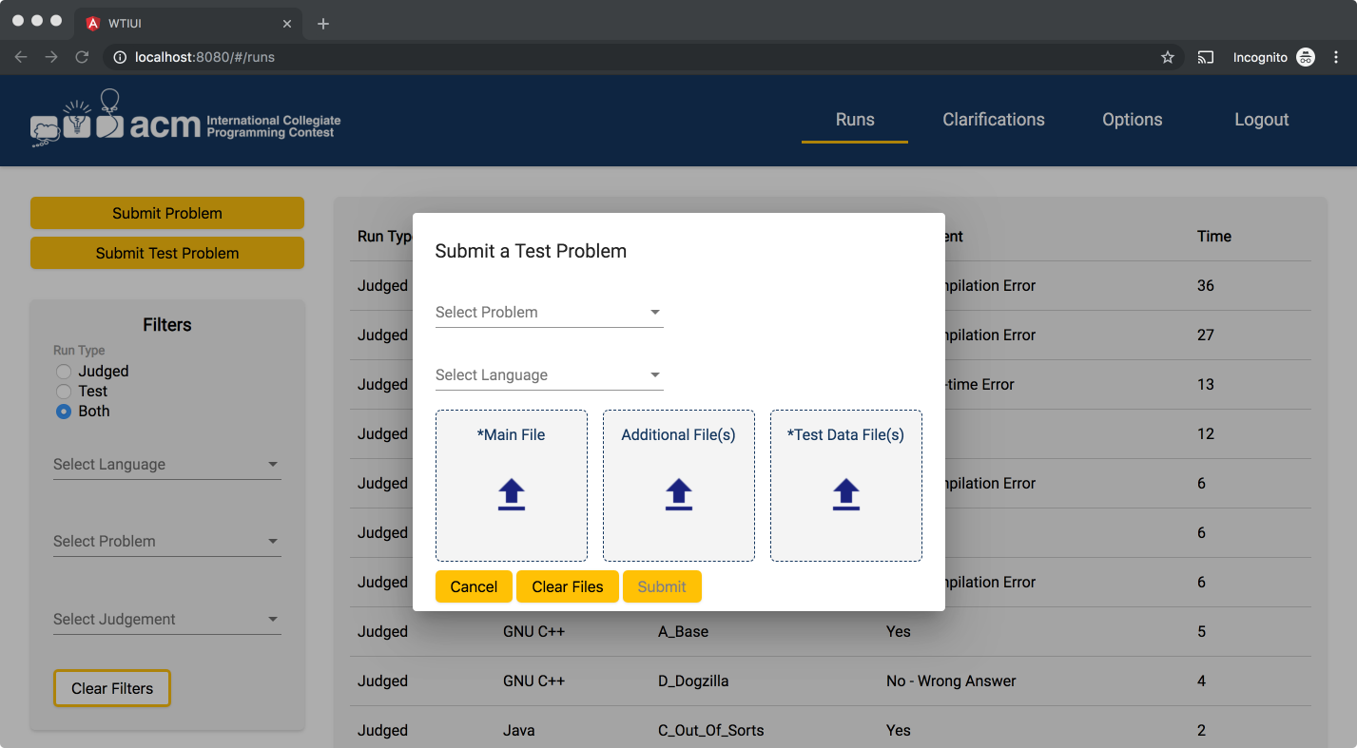

**View Clarifications**

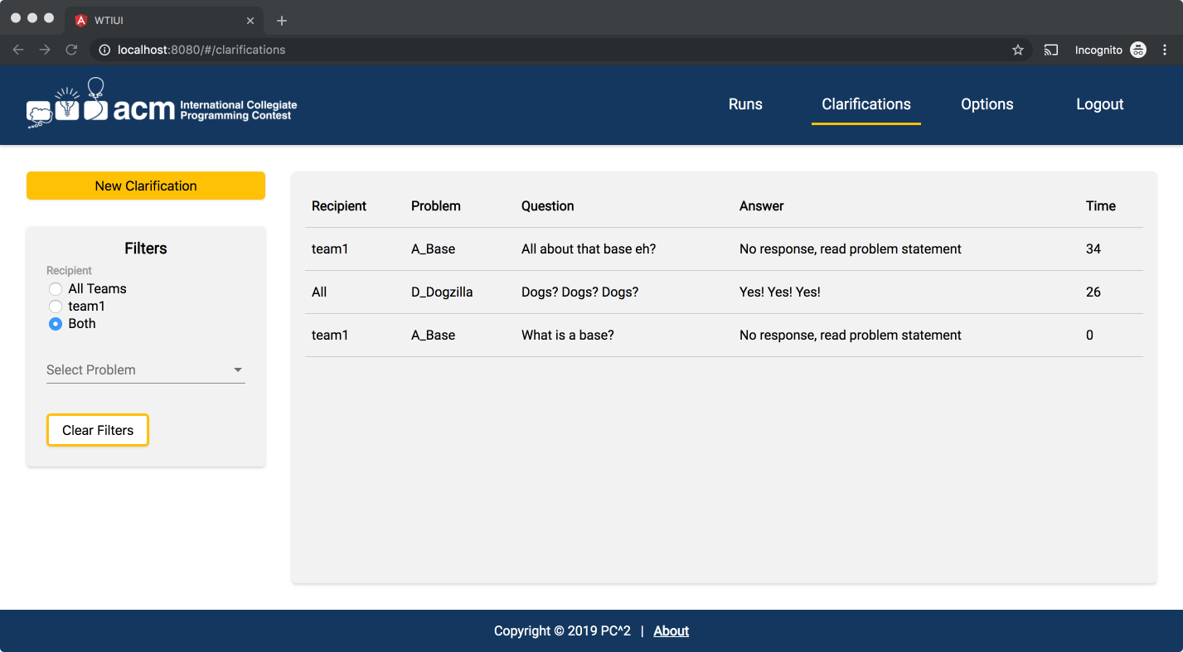

**Submit a Clarification**

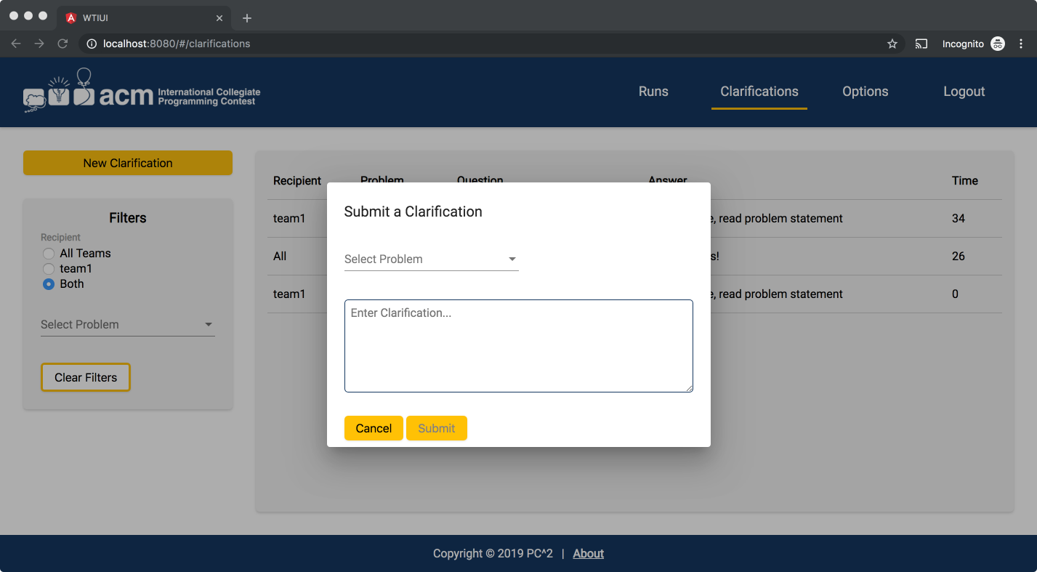

**View Options**

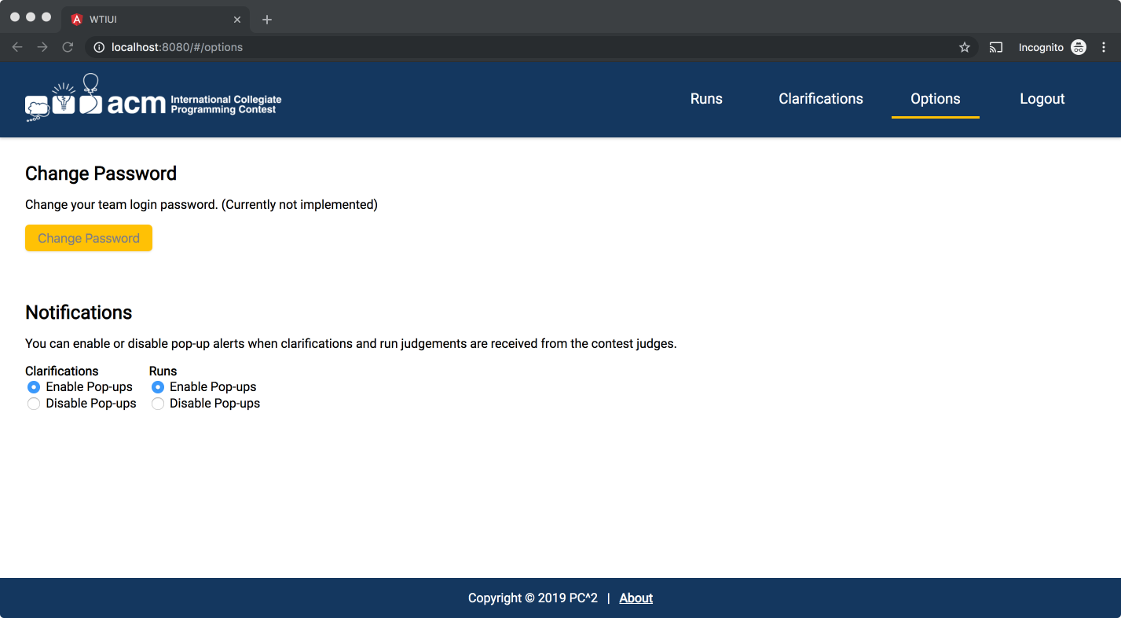

**View About Information**

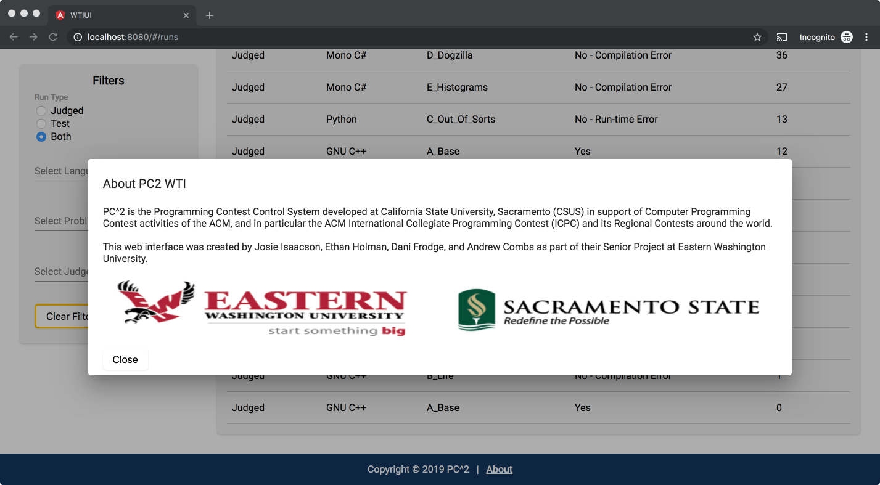

**Logout**

